SIMATS ENGINEERING

ASSESSMENT TOOL 1

COURSE NAME: CSA04 COURSE CODE: Operating Systems

COURSE OUTCOME COVERED

CO4: Optimize various file allocation strategies and disk scheduling algorithms to identify optimal methods for enhancing system performance.
Assessment Tool Weightage: 40%
Dr VIMAL V R

QUESTIONS: 5 Total Marks:25

Annexure A

CODING CHALLENGE/HACKATHON

Code of Conduct:

I PRIYADHARSHINI K S 192511248 (Name / Reg No) certify that this submission is my original work and that I have adhered to the guidelines specified for this assessment.
I understand that any violation of academic integrity rules will result in disciplinary action.

Signature of the student:
PRIYADHARSHINI K S
Annexure A

CODING CHALLENGE

S.No | Coding Challenge Questions | Marks
1 | Write a program to simulate the three file allocation methods—Contiguous, Linked, and Indexed. The program should accept inputs including the total disk size (number of blocks), the file size(number of blocks required),and the allocation method (1forContiguous, 2for Linked, 3 for Indexed). Based on the selected method, the program must allocate disk blocks accordingly, display the allocated block numbers, and handle fragmentation scenarios, particularly when contiguous allocation fails due to insufficient continuous space. The output should show the list of allocated blocks or an appropriate error message if allocation is not possible. Ensure that built-in memory allocation functions are not used, and assume that disk blocks are numbered starting from 0. | 5
2 | Develop a program to manage free disk space using a bitmap technique. The program should accept inputs including the total number of disk blocks, the initial bitmap (where 0 represents free and 1 represents allocated), and a request for allocation specifying the number of blocks required. The program must identify and allocate free blocks efficiently, update the bitmap after allocation, and also support deallocation of specified blocks with appropriate bitmap updates. The output should display the updated bitmap after allocation and deallocation operations. Ensure that the program efficiently searches for free blocks and properly handles  Cases where sufficient space is not available. | 5
3 | Implement a program that simulates at least three disk scheduling algorithms: FCFS, SSTF, and SCAN. The program should take as input the disk request queue, the initial head position, and the disk size. It must compute the total seek time for each algorithm, display the order in which disk requests are serviced, and compare their performance. The output should include the seek  sequence and total seek time for each algorithm, along with identification of the best-Performing algorithm based on minimum seek time. | 5
4 | Write a program to implement the C-SCAN and LOOK disk scheduling algorithms. The program should accept inputs including the request queue, the initial head position, and the direction of head movement (left or right). It must simulate both algorithms, calculate the total head movement required to service all requests, and compare their efficiency. The output should display the seek sequence, total head movement, and a conclusion indicating which  algorithm performs better along with a brief justification. Optionally, the program may include a graphical visualization of head movement. | 5
5 | Design a program that integrates file allocation strategies with disk scheduling techniques to optimize system performance. The program should accept inputs such as the total number of disk blocks, file size (number of blocks required), disk request queue, initial head position, allocation method (Contiguous or Indexed), and disk scheduling method (FCFS or SSTF). It must allocate disk blocks based on the chosen allocation strategy, simulate disk scheduling to access the allocated blocks, calculate the total seek time, and compare performance across different combinations. The output should display allocated blocks, seek sequence, total seek time, and identify the best combination of allocation and scheduling methods. Ensure the program handles allocation failures, avoids duplicate block allocation, and maintains efficient scheduling. | 5

RUBRICS FOR CALCULATION

Criteria | Weightage | Level 4 (Exemplary) | Level 3 (Proficient) | Level 2 (Developing) | Level 1 (Beginning)
Problem Understanding | 20% | Clearly understands problem constraints, edge cases, and competitive requirements | Understands problem with minor gaps in constraints | Partial understanding; misses key constraints | Misinterprets problem or constraints
Algorithm | 25% | Selects optimal algorithm with best time and space complexity for competitive constraints | Uses efficient algorithm with minor scope for improvement | Uses basic/inefficient approach | No clear algorithmic approach
Code Implementation | 20% | Writes correct, efficient, and clean code that passes all constraints | Code works with minor errors or inefficiencies | Partially correct code; fails for some cases | Code does not execute or gives incorrect results
Competitive Performance | 20% | Solves problem within time limits and handles large inputs effectively | Solves within acceptable time with minor delays | Struggles with time limits or larger inputs | Unable to solve within time constraints
Test Case Handling | 15% | Handles all test cases including edge and hidden cases | Handles most test cases | Misses important edge cases | Fails on multiple test cases

QUESTION 1 : File Allocation Methods

#include <stdio.h>

int main() {
int n, fileSize, method;
int disk[100] = {0};
int allocated[100];
int i, j, count, start = -1;
int indexBlock;

printf("Enter total number of disk blocks: ");
scanf("%d", &n);

printf("Enter file size (number of blocks): ");
scanf("%d", &fileSize);

printf("\n1. Contiguous\n");
printf("2. Linked\n");
printf("3. Indexed\n");
printf("Enter allocation method: ");
scanf("%d", &method);

if (fileSize <= 0 || fileSize > n) {
printf("Invalid file size or insufficient disk space.\n");
return 0;
}

/* Contiguous Allocation */
if (method == 1) {

for (i = 0; i <= n - fileSize; i++) {
count = 0;

for (j = i; j < i + fileSize; j++) {
if (disk[j] == 0)
count++;
else
break;
}

if (count == fileSize) {
start = i;
break;
}
}

if (start == -1) {
printf("Contiguous allocation failed.\n");
printf("Sufficient continuous space is not available.\n");
} else {
printf("\nContiguous Allocation:\n");
printf("Allocated blocks: ");

for (i = start; i < start + fileSize; i++) {
disk[i] = 1;
printf("%d ", i);
}

printf("\n");
}
}

/* Linked Allocation */
else if (method == 2) {

count = 0;

printf("\nLinked Allocation:\n");
printf("Allocated blocks: ");

for (i = 0; i < n && count < fileSize; i++) {
if (disk[i] == 0) {
disk[i] = 1;
allocated[count] = i;
printf("%d ", i);
count++;
}
}

if (count < fileSize) {
printf("\nAllocation failed. Not enough free blocks.\n");
} else {
printf("\nLinked sequence: ");

for (i = 0; i < fileSize; i++) {
printf("%d", allocated[i]);

if (i < fileSize - 1)
printf(" -> ");
}

printf(" -> NULL\n");
}
}

/* Indexed Allocation */
else if (method == 3) {

indexBlock = -1;

/* Find an index block */
for (i = 0; i < n; i++) {
if (disk[i] == 0) {
indexBlock = i;
break;
}
}

if (indexBlock == -1) {
printf("Indexed allocation failed.\n");
return 0;
}

disk[indexBlock] = 1;

count = 0;

/* Allocate data blocks */
for (i = 0; i < n && count < fileSize; i++) {
if (disk[i] == 0) {
disk[i] = 1;
allocated[count] = i;
count++;
}
}

if (count < fileSize) {
printf("Indexed allocation failed.\n");
return 0;
}

printf("\nIndexed Allocation:\n");
printf("Index block: %d\n", indexBlock);
printf("Allocated data blocks: ");

for (i = 0; i < fileSize; i++) {
printf("%d ", allocated[i]);
}

printf("\n");
}

else {
printf("Invalid allocation method.\n");
}

return 0;
}

OUTPUT :

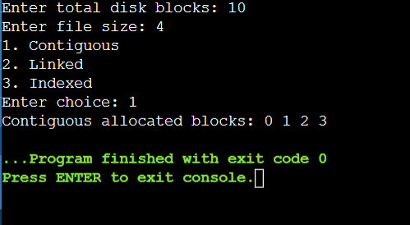

QUESTION 2: Bitmap Free-Space Management

#include <stdio.h>

int main()
{
int n, i, request;
int bitmap[100];
int block;

printf("Enter number of disk blocks: ");
scanf("%d", &n);

printf("Enter initial bitmap (0 = free, 1 = allocated):\n");

for (i = 0; i < n; i++)
scanf("%d", &bitmap[i]);

/* Allocation */
printf("Enter number of blocks to allocate: ");
scanf("%d", &request);

int count = 0;

for (i = 0; i < n && count < request; i++)
{
if (bitmap[i] == 0)
{
bitmap[i] = 1;
count++;
}
}

if (count < request)
{
printf("Not enough free blocks available.\n");
}
else
{
printf("Allocation successful.\n");
}

printf("Bitmap after allocation:\n");

for (i = 0; i < n; i++)
printf("%d ", bitmap[i]);

/* Deallocation */
printf("\nEnter block number to deallocate: ");
scanf("%d", &block);

if (block >= 0 && block < n && bitmap[block] == 1)
{
bitmap[block] = 0;
printf("Block %d deallocated successfully.\n", block);
}
else
{
printf("Invalid block or block is already free.\n");
}

printf("Bitmap after deallocation:\n");

for (i = 0; i < n; i++)
printf("%d ", bitmap[i]);

return 0;
}

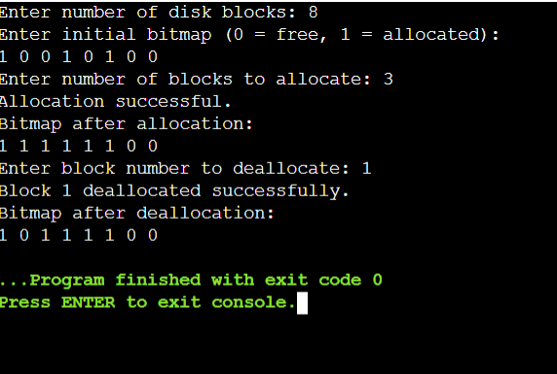

QUESTION 3: FCFS, SSTF and SCAN Disk Scheduling

#include <stdio.h>
#include <stdlib.h>

void fcfs(int request[], int n, int head)
{
int i, total = 0, current = head;

printf("\nFCFS Seek Sequence: %d", head);

for (i = 0; i < n; i++)
{
total += abs(current - request[i]);
current = request[i];
printf(" -> %d", current);
}

printf("\nTotal Seek Time = %d\n", total);
}

void sstf(int request[], int n, int head)
{
int visited[100] = {0};
int i, count, min, pos;
int total = 0, current = head;

printf("\nSSTF Seek Sequence: %d", head);

for (count = 0; count < n; count++)
{
min = 9999;
pos = -1;

for (i = 0; i < n; i++)
{
if (!visited[i] && abs(current - request[i]) < min)
{
min = abs(current - request[i]);
pos = i;
}
}

visited[pos] = 1;
total += abs(current - request[pos]);
current = request[pos];

printf(" -> %d", current);
}

printf("\nTotal Seek Time = %d\n", total);
}

void scan(int request[], int n, int head, int diskSize)
{
int i, j, temp;
int total = 0, current = head;

int arr[100];

for (i = 0; i < n; i++)
arr[i] = request[i];

/* Sort requests */
for (i = 0; i < n - 1; i++)
{
for (j = i + 1; j < n; j++)
{
if (arr[i] > arr[j])
{
temp = arr[i];
arr[i] = arr[j];
arr[j] = temp;
}
}
}

printf("\nSCAN Seek Sequence: %d", head);

/* Move towards right */
for (i = 0; i < n; i++)
{
if (arr[i] >= head)
{
total += abs(current - arr[i]);
current = arr[i];
printf(" -> %d", current);
}
}

/* Move to end of disk */
if (current != diskSize - 1)
{
total += abs(current - (diskSize - 1));
current = diskSize - 1;
printf(" -> %d", current);
}

/* Move towards left */
for (i = n - 1; i >= 0; i--)
{
if (arr[i] < head)
{
total += abs(current - arr[i]);
current = arr[i];
printf(" -> %d", current);
}
}

printf("\nTotal Seek Time = %d\n", total);
}

int main()
{
int request[100];
int n, head, diskSize;
int i;

printf("Enter number of disk requests: ");
scanf("%d", &n);

printf("Enter request queue:\n");

for (i = 0; i < n; i++)
scanf("%d", &request[i]);

printf("Enter initial head position: ");
scanf("%d", &head);

printf("Enter disk size: ");
scanf("%d", &diskSize);

fcfs(request, n, head);
sstf(request, n, head);
scan(request, n, head, diskSize);

return 0;
}

OUTPUT:
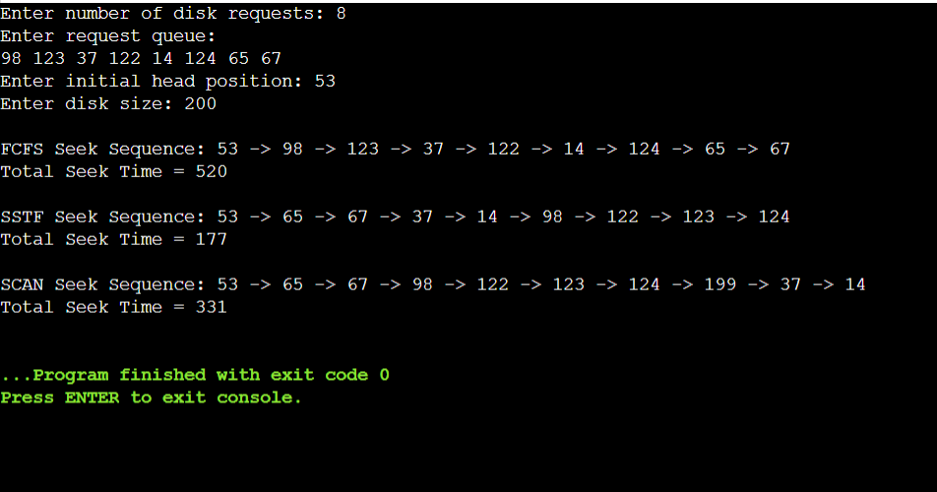

QUESTION 4: C-SCAN and LOOK Disk Scheduling

#include <stdio.h>
#include <stdlib.h>

void cscan(int request[], int n, int head, int diskSize, char direction)
{
int arr[100], i, j, temp;
int total = 0, current = head;

for (i = 0; i < n; i++)
arr[i] = request[i];

/* Sort requests */
for (i = 0; i < n - 1; i++)
{
for (j = i + 1; j < n; j++)
{
if (arr[i] > arr[j])
{
temp = arr[i];
arr[i] = arr[j];
arr[j] = temp;
}
}
}

printf("\nC-SCAN Seek Sequence: %d", head);

if (direction == 'R' || direction == 'r')
{
/* Move right */
for (i = 0; i < n; i++)
{
if (arr[i] >= head)
{
total += abs(current - arr[i]);
current = arr[i];
printf(" -> %d", current);
}
}

/* Go to end */
total += abs(current - (diskSize - 1));
current = diskSize - 1;
printf(" -> %d", current);

/* Jump to beginning */
total += diskSize - 1;
current = 0;
printf(" -> %d", current);

/* Continue right */
for (i = 0; i < n; i++)
{
if (arr[i] < head)
{
total += abs(current - arr[i]);
current = arr[i];
printf(" -> %d", current);
}
}
}
else
{
/* Move left */
for (i = n - 1; i >= 0; i--)
{
if (arr[i] <= head)
{
total += abs(current - arr[i]);
current = arr[i];
printf(" -> %d", current);
}
}

/* Go to beginning */
total += current;
current = 0;
printf(" -> %d", current);

/* Jump to end */
total += diskSize - 1;
current = diskSize - 1;
printf(" -> %d", current);

/* Continue left */
for (i = n - 1; i >= 0; i--)
{
if (arr[i] > head)
{
total += abs(current - arr[i]);
current = arr[i];
printf(" -> %d", current);
}
}
}

printf("\nC-SCAN Total Head Movement = %d\n", total);
}

void look(int request[], int n, int head, char direction)
{
int arr[100], i, j, temp;
int total = 0, current = head;

for (i = 0; i < n; i++)
arr[i] = request[i];

/* Sort requests */
for (i = 0; i < n - 1; i++)
{
for (j = i + 1; j < n; j++)
{
if (arr[i] > arr[j])
{
temp = arr[i];
arr[i] = arr[j];
arr[j] = temp;
}
}
}

printf("\nLOOK Seek Sequence: %d", head);

if (direction == 'R' || direction == 'r')
{
/* Move right */
for (i = 0; i < n; i++)
{
if (arr[i] >= head)
{
total += abs(current - arr[i]);
current = arr[i];
printf(" -> %d", current);
}
}

/* Reverse */
for (i = n - 1; i >= 0; i--)
{
if (arr[i] < head)
{
total += abs(current - arr[i]);
current = arr[i];
printf(" -> %d", current);
}
}
}
else
{
/* Move left */
for (i = n - 1; i >= 0; i--)
{
if (arr[i] <= head)
{
total += abs(current - arr[i]);
current = arr[i];
printf(" -> %d", current);
}
}

/* Reverse */
for (i = 0; i < n; i++)
{
if (arr[i] > head)
{
total += abs(current - arr[i]);
current = arr[i];
printf(" -> %d", current);
}
}
}

printf("\nLOOK Total Head Movement = %d\n", total);
}

int main()
{
int request[100];
int n, head, diskSize;
int i;
char direction;

printf("Enter number of disk requests: ");
scanf("%d", &n);

printf("Enter request queue:\n");
for (i = 0; i < n; i++)
scanf("%d", &request[i]);

printf("Enter initial head position: ");
scanf("%d", &head);

printf("Enter disk size: ");
scanf("%d", &diskSize);

printf("Enter direction (R for Right, L for Left): ");
scanf(" %c", &direction);

cscan(request, n, head, diskSize, direction);
look(request, n, head, direction);

return 0;
}
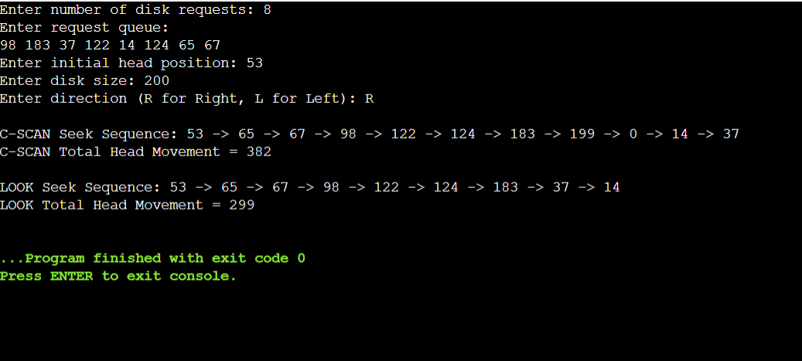

Question 5 – File Allocation + Disk Scheduling
#include <stdio.h>
#include <stdlib.h>

int main()
{
int n, fileSize;
int request[100], r;
int head;
int allocation, scheduling;
int disk[100] = {0};
int allocated[100];
int i, j, count;
int total, current;

printf("Enter total disk blocks: ");
scanf("%d", &n);

printf("Enter file size: ");
scanf("%d", &fileSize);

printf("1. Contiguous\n");
printf("2. Indexed\n");
printf("Enter allocation method: ");
scanf("%d", &allocation);

/* FILE ALLOCATION */

count = 0;

if (allocation == 1)
{
int found = 0;

for (i = 0; i <= n - fileSize; i++)
{
count = 0;

for (j = i; j < i + fileSize; j++)
{
if (disk[j] == 0)
count++;
else
break;
}

if (count == fileSize)
{
printf("\nContiguous allocated blocks: ");

for (j = i; j < i + fileSize; j++)
{
disk[j] = 1;
allocated[count - fileSize + (j - i)] = j;
printf("%d ", j);
}

found = 1;
break;
}
}

if (!found)
{
printf("Contiguous allocation failed.\n");
return 0;
}
}

else if (allocation == 2)
{
int indexBlock = -1;

/* Find index block */
for (i = 0; i < n; i++)
{
if (disk[i] == 0)
{
indexBlock = i;
disk[i] = 1;
break;
}
}

if (indexBlock == -1)
{
printf("No index block available.\n");
return 0;
}

count = 0;

for (i = 0; i < n && count < fileSize; i++)
{
if (disk[i] == 0)
{
disk[i] = 1;
allocated[count] = i;
count++;
}
}

if (count < fileSize)
{
printf("Indexed allocation failed.\n");
return 0;
}

printf("\nIndex block: %d", indexBlock);
printf("\nIndexed allocated blocks: ");

for (i = 0; i < fileSize; i++)
printf("%d ", allocated[i]);
}

else
{
printf("Invalid allocation method.\n");
return 0;
}

/* DISK REQUEST QUEUE */

printf("\n\nEnter number of disk requests: ");
scanf("%d", &r);

printf("Enter disk request queue:\n");

for (i = 0; i < r; i++)
scanf("%d", &request[i]);

printf("Enter initial head position: ");
scanf("%d", &head);

printf("\n1. FCFS\n");
printf("2. SSTF\n");
printf("Enter scheduling method: ");
scanf("%d", &scheduling);

/* FCFS */

if (scheduling == 1)
{
total = 0;
current = head;

printf("\nFCFS Seek Sequence: %d", head);

for (i = 0; i < r; i++)
{
total += abs(current - request[i]);
current = request[i];

printf(" -> %d", current);
}

printf("\nTotal Seek Time = %d\n", total);
}

/* SSTF */

else if (scheduling == 2)
{
int visited[100] = {0};
int min, pos;

total = 0;
current = head;

printf("\nSSTF Seek Sequence: %d", head);

for (i = 0; i < r; i++)
{
min = 9999;
pos = -1;

for (j = 0; j < r; j++)
{
if (!visited[j] &&
abs(current - request[j]) < min)
{
min = abs(current - request[j]);
pos = j;
}
}

visited[pos] = 1;
total += abs(current - request[pos]);
current = request[pos];

printf(" -> %d", current);
}

printf("\nTotal Seek Time = %d\n", total);
}

else
{
printf("Invalid scheduling method.\n");
return 0;
}

printf("\nIntegration completed successfully.\n");

return 0;
}
